Secondary Math 2 Unit 2 Review Name: ________________________ Period: _______

1-2 Find the measure of angle A
1.
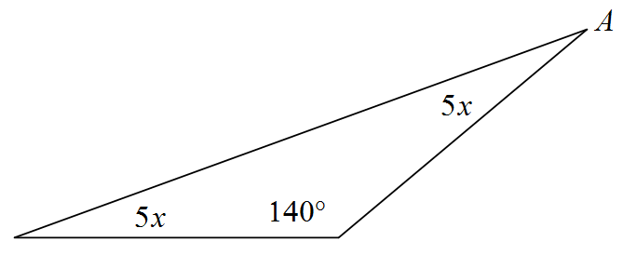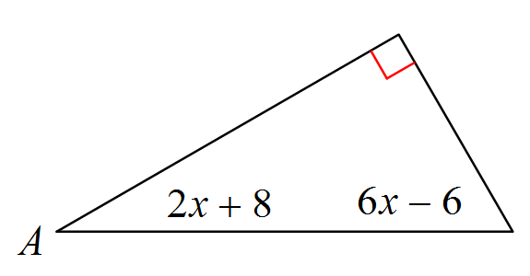2.

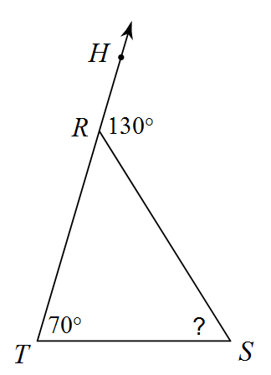3. Find $m∠S$ 4. Find $m∠B$
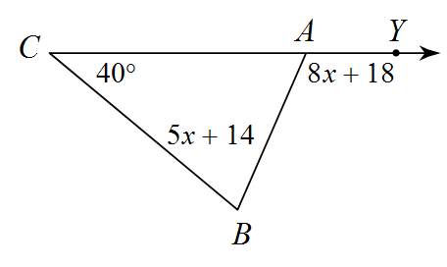

- Find$m∠W$. 6. Find measure of$∠x$.
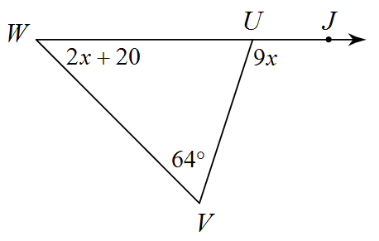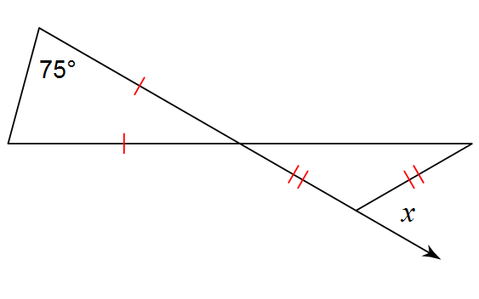

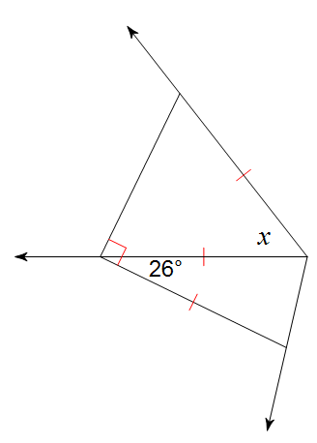7. Find measure of$∠x$. 8. Given that points N, P, & M are mid points,
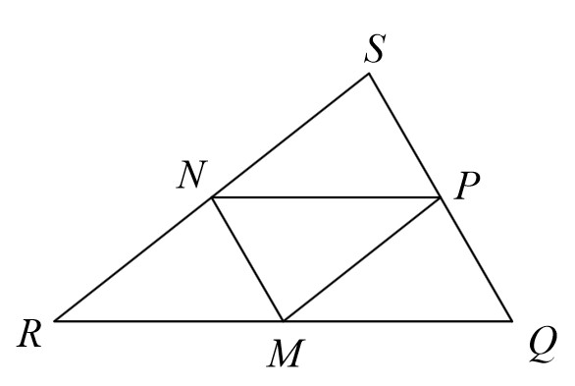 and given $\overline{NM} = 7$, $\overline{RQ} = 18$, ∠SNP = 45𝑜
  - Find the length of NP

  - Given that $\overline{SN}=7.5,$Find the perimeter of ∆RSQ

  - Find ∠SRQ

- Solve for x.
- Find the missing side length.
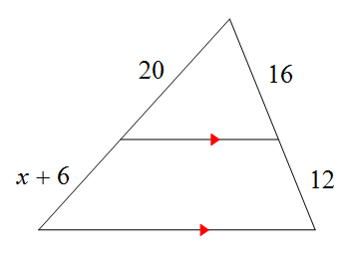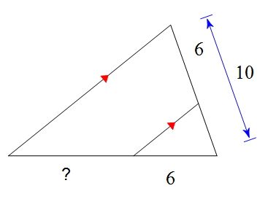

- Solve for x. 12. Solve for x.
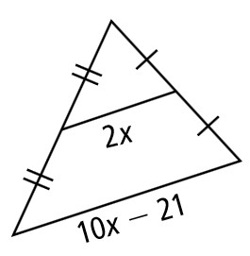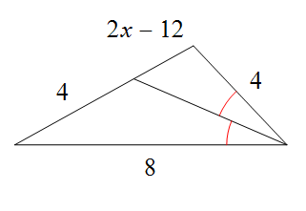

13. Find the missing side length. 14. Given the parallelogram,
solve for m and n.
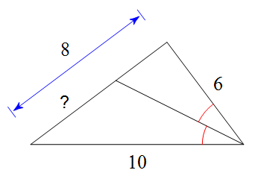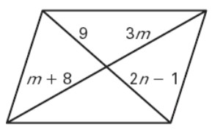

15. Given the parallelogram, solve for f and g. 16. Given the parallelogram,
solve for x and y.
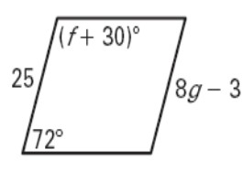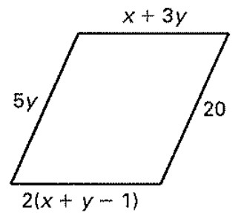

17. Given the parallelogram,
Solve for x and find $m∠L$. 18. BE = 51.2, EC = 38.4, DA = 15, BD= 20. Is $\overline{AC} ||\overline{DE }?$ Justify.
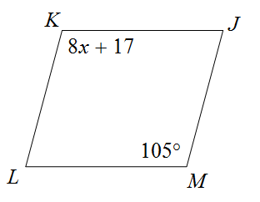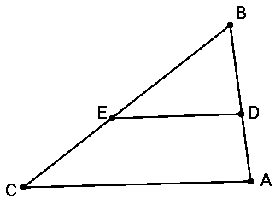

- Given the vertices
A(−4,4), B(−2,7), C(2,0) Classify the triangle as scalene, isosceles, or equilateral. Is the triangle a right triangle? Explain.
- Given the vertices
A(1, −1), B(7, −1), C(4, −5) Classify the triangle as scalene, isosceles, or equilateral. Is the triangle a right triangle? Explain.

- What is the most precise classification of the quadrilateral formed by the given vertices:
T (−3,3), U (1,6), V (1,1), 𝑎n𝑑 W (−3, −2)
Show your work.

- Prove or disprove that the given vertices form a parallelogram.
T (2,2), U (3,4), V (7,2), 𝑎n𝑑 W (8,5).
Show your work.

