**Secondary Math 2 Unit 4 Review Name: ___________________________ Period: _____**

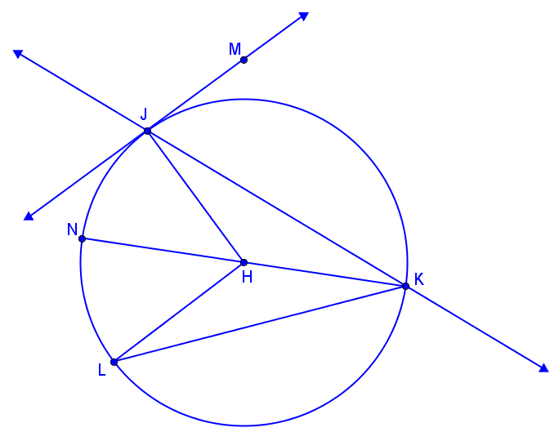Matching: Select the vocabulary term that describes each object listed from the list on the right. Each vocabulary term must be used exactly once.

|  |  |  |  |
| --- | --- | --- | --- |
| ___ |  | 1. Radius |  |
| ___ |  | 1. Point of tangency |  |
| ___ |  | 1. Chord that is not a diameter |  |
| ___ |  | 1. Diameter |  |
| ___ |  | 1. Center of circle |  |
| ___ |  | 1. Inscribed Angle |  |
| ___ |  | 1. Central Angle |  |
| ___ |  | 1. Tangent Line |  |

|  |  |
| --- | --- |
| 1. Use the figure to answer the questions below:   find arc length, r=7, theta=90.PNG   1. Classify minor semicircle major 2. What is the measure of ? 3. What is the circumference of the circle? 4. What is the length of ? 5. What is the area of ? 6. What is the area of sector | 1. Use the figure to anwer the questions below:   find arc length, r=12, theta=120.PNG   1. Classify minor semicircle major 2. What is measure of ? 3. What is the circumference of the circle? 4. What is the length of ? 5. What is the area of ? 6. What is the area of sector |
| 1. find arc length, r=7, theta=90.PNG   a. What type of angle is ?  b. | 1. find arc length, r=7, theta=90.PNG   a. What type of angle is ?  b. |
| 1. find arc length, r=7, theta=90.PNG   a. What type of angle is ?  b. | 1. Solve for x. |
| 1. Find the measure of $∠C$. | a. What is the value c?  b. Find the |
| 1. Determine if line AB is tangent to the circle. | 1. Determine if line AB is tangent to the circle. |
| 1. Find the segment length indicated. Assume that lines that appear to be tangent are tangent. | 1. Find the segment length indicated. Assume that lines that appear to be tangent are tangent. |
| 1. Solve for x. Assume that lines that appear to be tangent are tangent. | 1. Solve for x. Assume that lines that appear to be tangent are tangent. |
| 1. Give the radius and the center and then graph:   find equation2.PNG | 1. Give the radius and the center and then graph:   find equation2.PNG |
| 1. Write the equation of the circle. find equation2.PNG | 1. Write the equation of the circle. find equation1.PNG |
| 1. Write the equation of the circle. find equation2.PNG | 1. Write the equation of the circle with the given information:  Center: $\left(253, -967\right)$ Diameter: |
| 1. Show that the circles are similar by describing the transformations that map $⨀R$ onto $⨀T.$ State the scale factor. | |